***THE RAS UM SID***

Ras Um Sid Beach is another popular destination in Sharm El Sheikh, Egypt, known for its stunning underwater scenery and relaxed atmosphere. Here's a brief overview:

1. **Location**: It's located south of Naama Bay, about a 10-minute drive away, making it easily accessible from the main tourist areas.

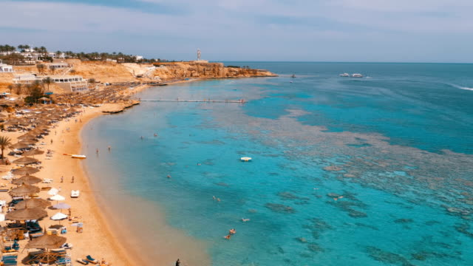

Ras Um Sid is famous among snorkelers and divers for its vibrant coral reefs and diverse marine life. The underwater scenery is spectacular, with colorful fish, corals, and sometimes even sightings of turtles and rays.

The beach area itself is more laid-back compared to Naama Bay, offering a quieter environment with fewer commercial establishments. However, there are still facilities like sunbeds and umbrellas available for visitors.